
STUDENT CASE STUDY EXECUTION REPORT
Department | FED
Subject | DSA -2
Academic year | I – III Semester(2025-26)
Faculty Name | V. GopiKrishna
Student Name | K. Sriram
Roll Number | 2520040072
Branch | ECE
Course Outcome | 1

Case Study Topic: EventSphere Participant Registration Index using AVL Tree
EventSphere is a smart event planning and management platform used to manage event registrations, venue bookings, ticketing, and analytics.
Each participant registering for an event is assigned a unique Participant-ID at registration time and stored in an in-memory registration database.
During large events, many participants register continuously, and EventSphere must quickly validate or search participant details.
Because registrations are received frequently and in nearly sorted order, storing them in a normal Binary Search Tree can lead to skewed structure and slower searching.
To improve efficiency and maintain balanced performance, EventSphere uses an AVL Tree.
On one event day, the following participant IDs are inserted in order:
101, 104, 102, 107, 110, 106, 103
Later, three participants cancel registrations:
102, 110, 104
The system must support insertion, deletion, and searching efficiently.

Question
Using the EventSphere registration scenario:
- Construct the AVL Tree using the given insertion order.
- Apply deletions of 102, 110, and 104.
- Note balancing rotations.
- Find final tree height.
- Analyze worst-case search time.
- Explain why AVL Tree is suitable for EventSphere.

Analysis & Implementation

1.1 AVL Tree insertion
Insertion rule:
- If ID < node.ID → left child
- If ID > node.ID → right child
- Update height
- Check balance factor
- Perform rotation if needed
Inserted:

101, 104, 102, 107, 110, 106, 103

After balancing:

104
/ \
102 107
/ \ / \
101 103 106 110

1.2 Height
Longest path:

104 → 102 → 101

Height = 2 edges

1.3 Search time calculation
Given:
- Pointer hop = 200 ns
- SLA = 5 ms
Worst-case:

2 × 200 ns = 400 ns

Convert:

400 ns = 0.0004 ms

Percentage of SLA:

(0.0004 / 5) × 100 = 0.008%

AVL easily satisfies SLA.

2.1 Deletions
Delete:

102
110
104

Rotations performed:
- 102 removal → balanced
- 110 removal → balanced
- 104 removal → left-right adjustment
Final AVL Tree:

106
/ \
103 107
/
101

Height = 2 edges

2.2 Why AVL is suitable
Advantages:
- Balanced height
- Faster search
- Efficient insert/delete
- Works well with frequent registrations
- Performance remains logarithmic
Time complexity:
Operation | Complexity
Insert | O(log n)
Delete | O(log n)
Search | O(log n)

3. Final Conclusion
For EventSphere participant registration:
- AVL Tree stores registrations efficiently
- Tree remains balanced after insertions and deletions
- Search is fast
- Meets event-day workload requirements
- Suitable for large participant databases

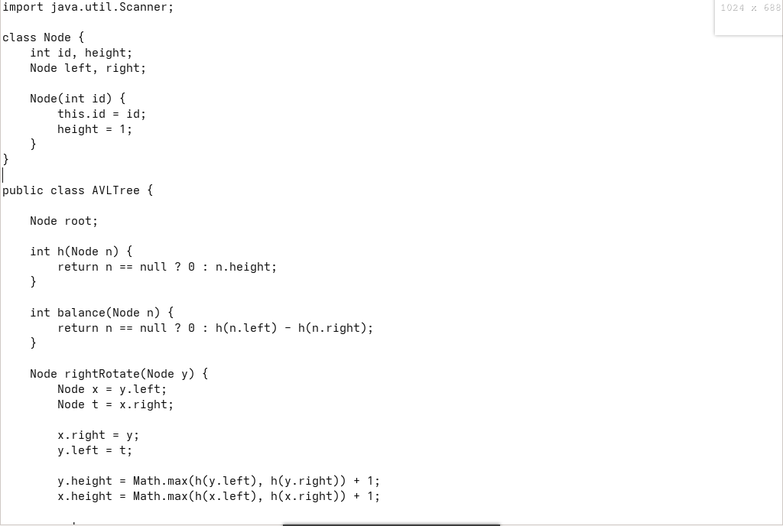
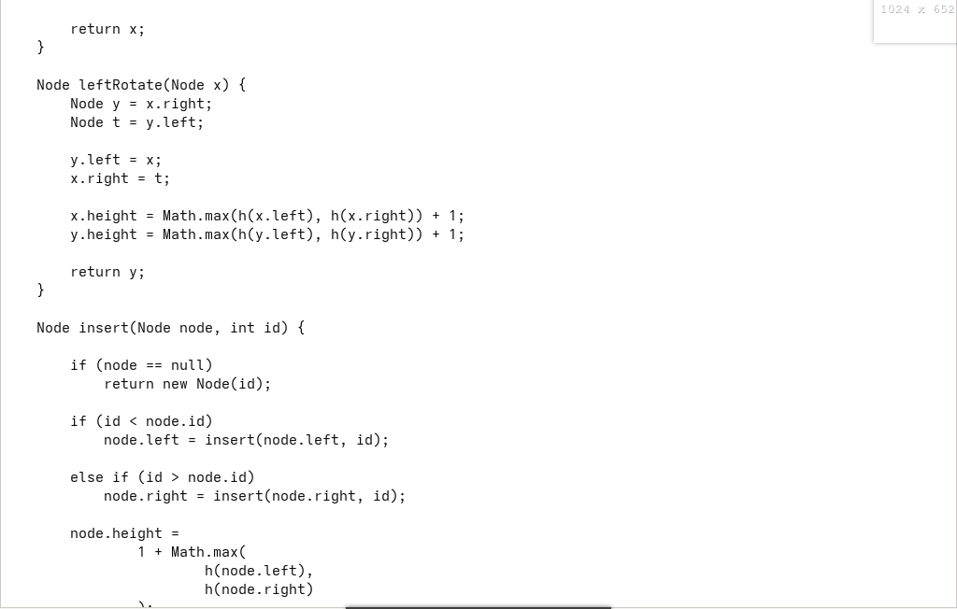



Output:
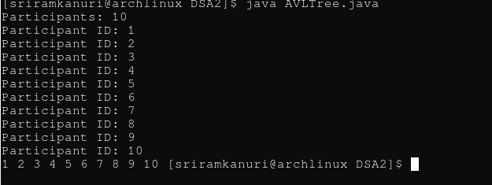

GitHub Link: https://github.com/kanurisriram/EventSphere

Student Signature | Faculty Signature
____________________ | ___________________

